**Chapter 1:Introduction**

**Introduction**

There are many good websites to convert PDF online but PDF HUB can be regarded as one of the best among them. It is a simple yet sophisticated platform that allows you to do all kinds of conversions online without bordering you with installing any software. You can convert PDF to excel, word, image, Txt and others while you can also convert these formats back to PDF right on this platform. It is one of the easiest platform for Word file convert to PDF online and also secured as files are erased from the server after just one hour of conversion.

You can convert password protected PDF file through this site. You need to register your email id with this site and they will send the converted file to your inbox. This site does not send any virus or scammed file to your email id.

This cloud-based PDF maker can be used to manage and organize your PDF documents, compress files to email large PDFs, merge multiple sources into a single PDF, and convert to and from a PDF file. Some of the top features include download link management, PDF splitting, adding a watermark, and easy Office to PDF conversions. PDF HUB can increase the file size of your PDFs without destroying the quality of the files. You can then email larger PDF documents, such as reports or catalogs. If you prefer to send a link, you can create a shareable download link right from the platform.

The Unlock PDF feature is another commonly talked about component of PDF HUB. You can also remove password security from PDFs to give greater freedom to your users as well. This website allows you to add watermarks to your pages, add page numbers, and rotate elements. If you use Microsoft Office, you can even convert to and from Office files to create documents, presentations, and spreadsheets for your business

**Chapter 2:**

**Design Thinking Phase**

**2.1) AEIOU Canvas**

AEIOU canvas describe us overall idea about all details about job hunt.

* Environment:

It include the entire arena where activities take place. We describe general impression, elements, and features.

* Cloud Storage
* Interaction:

These happen between a person and someone or something else, they are the building block of activities. In general impression we describe.

* User to Browser
* User to Mobile
* Object:

These are the building blocks of environment. We describe objects which include:

* Mobile
* Laptop/Desktop
* Internet
* Activities:

These are the goal directed sets of actions paths towards things people want to accomplish. What are the modes people work in, and the specific activities and processes they go through. In general we describe that what is going on the site. Here people are engaged in some other activities some of them are mention below:

* Login – Connects with the server to store the data.
* Uploading – Used to upload the file to the server.
* Converting
* Searching – Provide the ability to find any file
* Editing – Use to edit the file
* Downloading – Download the converted file
* Sharing – Use to share the file.
* User’s:

Users are the people whose behaviours, preference, and needs are being observed. In elements we describe

* Student
* Parent’s
* Expert’s
* Professor

**2.2) Empathy Phase**

Empathy Mapping is the first step when you go into study design engineering and it is the first chart for the first canvas that you will be making when you start with your design engineering project course.

* User’s:

Users are the people whose behaviours, preference, and needs are being observed. In elements we describe

* Student
* Parent’s
* Expert’s
* Professor
* Stakeholders:

Stakeholders are those who are going to get a direct or an indirect income because of these users so write down the number n number of names of these stakeholders in this particular column of stakeholders.

* IT Companies
* Entrepreneurs
* Activities:

These are the goal directed sets of actions paths towards things people want to accomplish. What are the modes people work in, and the specific activities and processes they go through. In general we describe that what is going on the site. Here people are engaged in some other activities some of them are mention below:

* Login – Connects with the server to store the data.
* Uploading – Used to upload the file to the server.
* Converting
* Searching – Provide the ability to find any file
* Editing – Use to edit the file
* Downloading – Download the converted file
* Sharing – Use to share the file.
* Story Boarding
* Happy

1. I am a office employee and i am so happy that i finally found the platform which includes pdf to .mobi, pdf to epub, pdf to excel etc functionalities is one platform that server my lots of time.
2. I am student and i am so happy that i get the manifesto for my period in that manifesto they provide all the features that i required for my project.

* Sad

1. I am a office employee, So in my work i have to convert pdf to .mobi, pdf to epub etc But i am not satisfied with any app or website that can provide this all functionalities on one platform. Due to this my work consume more time because i have to switch the platform for my work.
2. As being student it is difficult to find all the functions in one platform like pdf to excel, pdf to ppt, pdf to work etc for my project or submission.

**2.3) Problem Definition by Prior Art Search**

* This type of project is already existing but that project is providing only some extension or tools, So many tools such as Pdf to Word, Pdf to image, Pdf to excel and Pdf to PowerPoint are came in that but in our project we will provide that all options but also we are providing tools like Pdf to.mobi, Pdf to epub, Pdf to OneNote etc.
* This project is designed for helping students, IT professional, Professors and General Users to do their work easily in day to day life. The basic aim is to provide all the extension or tools (Pdf to Word, Pdf to image, Pdf to excel and Pdf to PowerPoint, Pdf to.mobi, Pdf to epub, Pdf to OneNote etc) in one website. Pdf Hub is a Web based system that is design to give all the extension in one website to the Users that are searching for. Aim is to provide a platform which can help all the users without any problem.
* In our website we will provide all in one things like if we want to convert pdf or if we want to resize any image or some other things than for this we have to go for multiple websites to do that things but in our website we provide all features at one place.
* We choosed this domain because in now a day, we all know that there are many apps that can convert pdf or to any other document but not all in one like for image resize we have to go one website and for pdf conversion we have to go for another website.

**2.4) Ideation Phase**

* People:
* IT Professional
* Professor
* Student
* General User’s
* Activities:

These are the goal directed sets of actions paths towards things people want to accomplish. What are the modes people work in, and the specific activities and processes they go through. In general we describe that what is going on the site. Here people are engaged in some other activities some of

them are mention below:

* Login – Connects with the server to store the data.
* Uploading – Used to upload the file to the server.
* Converting
* Searching – Provide the ability to find any file
* Editing – Use to edit the file
* Downloading – Download the converted file
* Sharing – Use to share the file.
* Situation/Context/Location:
* Invalid Extension
* Password encrypted file
* Damaged / Incomplete file
* Props/Possible Solutions
* Password encrypted file – Auto decrypted file
* PDF to any file

**2.5) Product Development Phase**

* Purpose:
* Convert File
* Edit File
* Merge File
* Protect File
* People:
* Professor
* Students
* IT expert
* General Users
* Product Experience
* User
* Friendly
* Good UI
* Free of cost
* Product Functions
* Download
* Upload
* Search
* Product Features
* Effective Connecting
* Sharing
* Feedback Option
* Components
* JavaScript
* Boot Strap
* SQL
* Customer Revalidation
* Good Performance
* Bug- Free
* User Friends
* Easy to Use
* Reject, Redesign, Retain
* No unnecessary Permission
* High Speed Performance

**2.6)Mind Map**

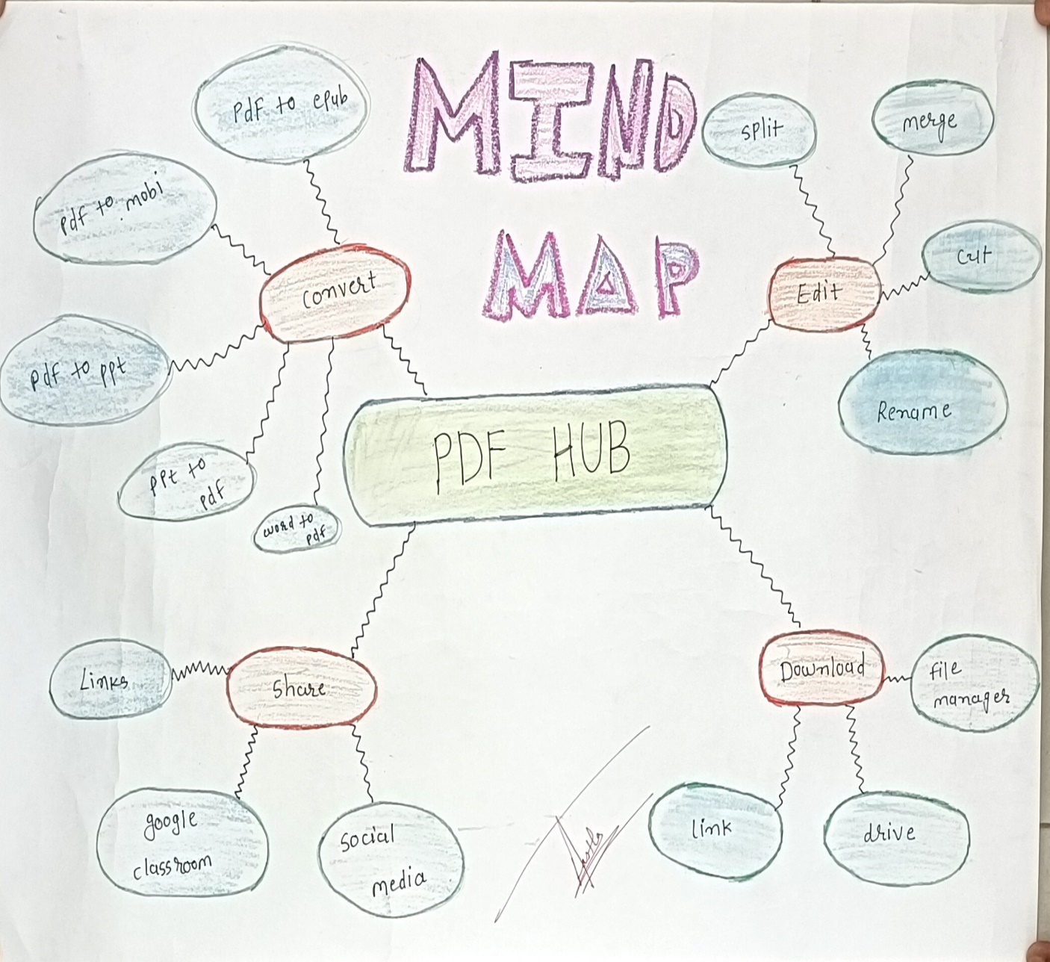

**2.7)Learning Needs Matrix**

1. **Purpose/Product concept:**

PDF Converter

1. **Tools/Methods/Theories/Application process involved:**

During BE IV: HTML, CSS, PHP, Bootstrap.

During BE III: Visual Studio Code.

During BE II: C & C++ Language.

1. **Application Standards and design/Specification/Principles and Experiment:**

During BE IV: File Type Conversion.

During BE III: Pdf 2.0

During BE II: Connect to technology.

1. **Component material’s strength criteria:**

During BE IV: Adobe content pane, Tag pane, Accessibility full checker

During BE III: Js-pdf and react-dom/server

During BE II: Stable Internet

1. **Software/Simulation/Skill/Mathematical Requirement:**

During BE IV: Compress, Convert and Collaborate

During BE III: Coding

During BE II: VS code, Xampp

**Chapter 3:**

**Feedback Analysis with User**

**Feedback Analysis with User**

It’s easy to use, no need to download, can convert online directly, best part is can convert any documents to pdf or vice versa. Only we need to watch ad which is fare enough as we don't need to pay a penny for it and get things work free of cost.PDF Convert free easy to use and requires no installation. The conversion happens online and free of cost. We can convert any files to any format without the watermark. It has got lots of cool features to explore and experiment. I deal with many PDF contracts, and whenever I need them converted, I use PDF HUB, and it works like a charm. It is fast, efficient, and free!

The ease of uploading and the benefit of uploading the document/file to almost all possible formats is best about this site. It has immensely helped me in my day-to-day life. It is an easy, fast and friendly way to get any document into a pdf or a pdf into any other document you need with in seconds and effortless PDF HUB easy to use and requires no installation. The conversion happens online and free of cost. We can convert any files to any format without the watermark. It has got lots of cool features to explore and experiment

**Chapter 4:**

**Conclusion**

**Conclusion**

Every tool you need to use PDFs, at your fingertips. All are 100% FREE and easy to use! Merge, split, compress, convert, rotate, unlock and watermark PDFs with just a few clicks. PDF HUB is best website for editing PDF with ease. Enjoy all the tools you need to work efficiently with your digital documents while keeping your data safe and secure.

With these pdf converters, you can not only convert your file to PDF but also edit your PDF file. They provide a lot of PDF tools for our daily use of PDF files, which can meet almost all basic needs. You can create or convert PDF files all in a single place. This PDF creator supports Excel, Word, PPT, JPG, PNG, BMP, TIFF & GIF

Today there are many free online PDF solutions available on the Internet. The only problem is that they we have to go different websites for our work, unlike software. That’s why PDF HUB is a much more practical solution for us. In addition, while uploading and converting a document on PDF HUB in your computer is now essential to access most documents online and offline, PDF conversion is especially important for professionals and students who regularly use PDF. So before you upload and convert the first document, it is important to define your needs, which will avoid many disappointments.

**Chapter 5:**

**References**

**References**

[1]Smallpdf

<https://smallpdf.com/>

[2]ilovepdf

<https://www.ilovepdf.com/>

[3]Sodapdf

<https://www.sodapdf.com/>

[4]Online Pdf Converter

<https://www.freepdfconvert.com/>

**Chapter 6:**

**APPENDIX-A**

**APPENDIX – A**

* **AEIOU Canvas**

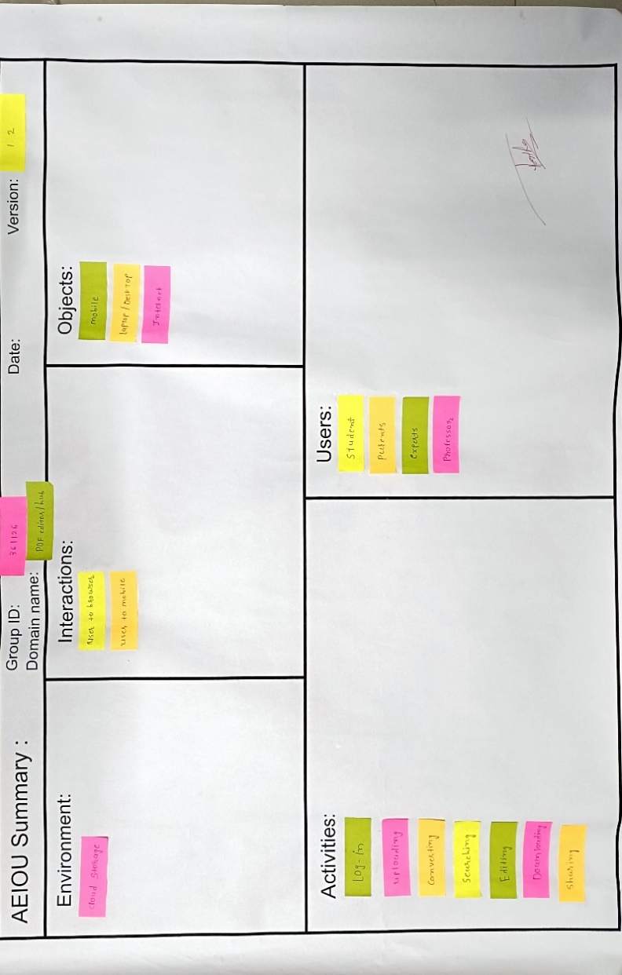

AEIOU

* **Empathy Canvas**

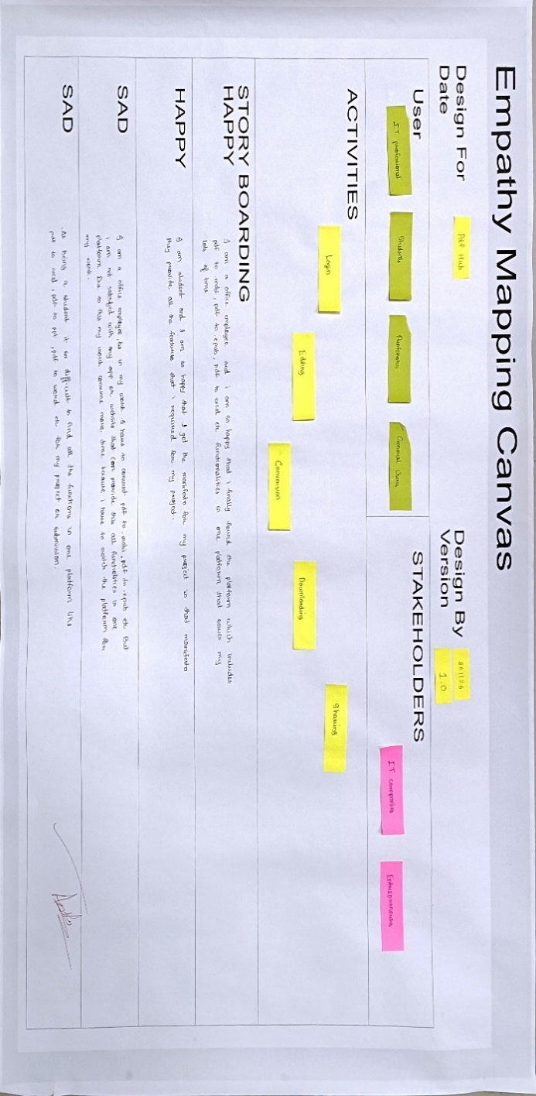

Empathy Canvas

* **Ideation Canvas**

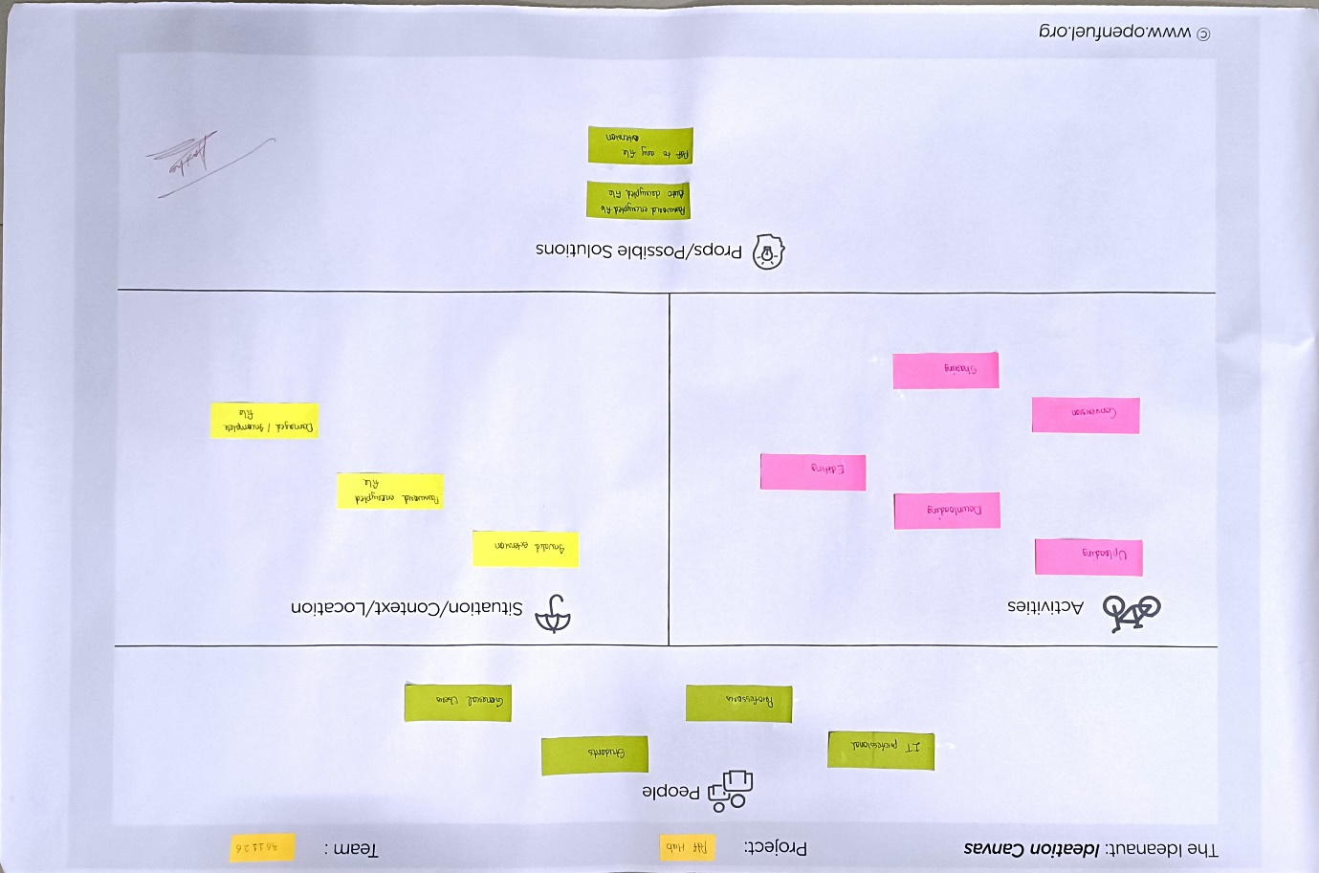

Ideation Canvas

* **Product Development Canvas**

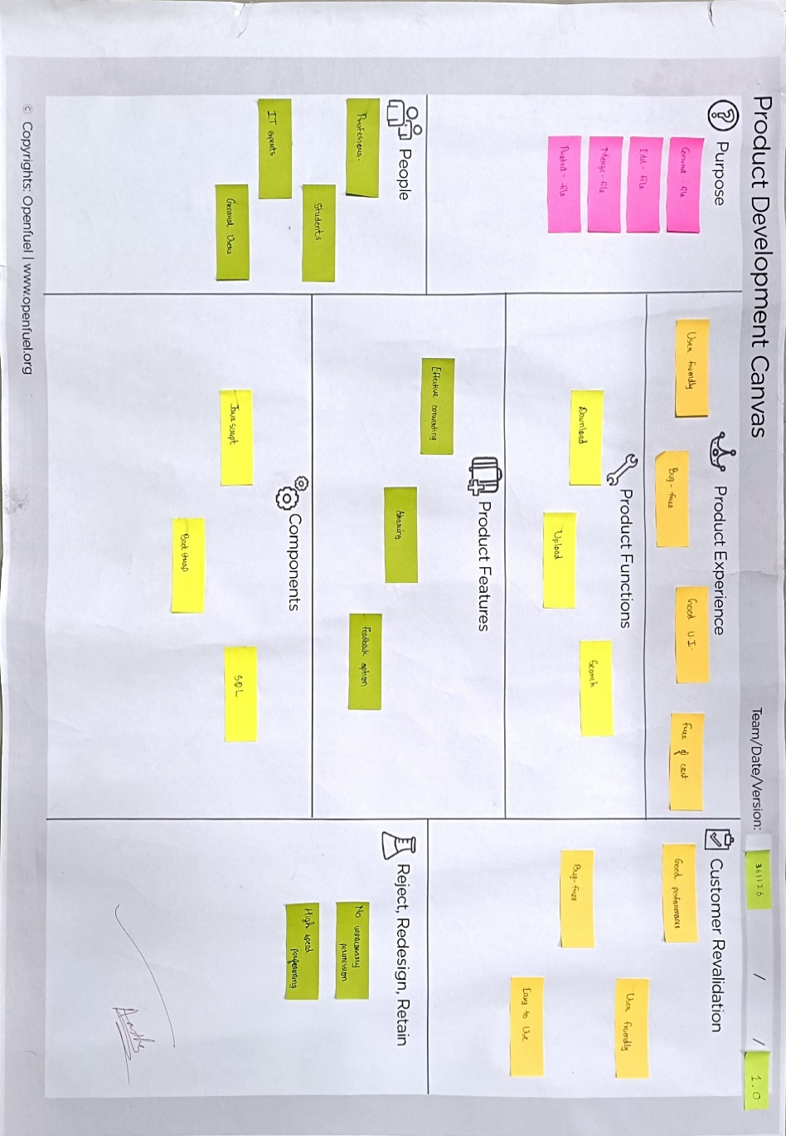

Product Development Canvas

* **Mind Mapping**

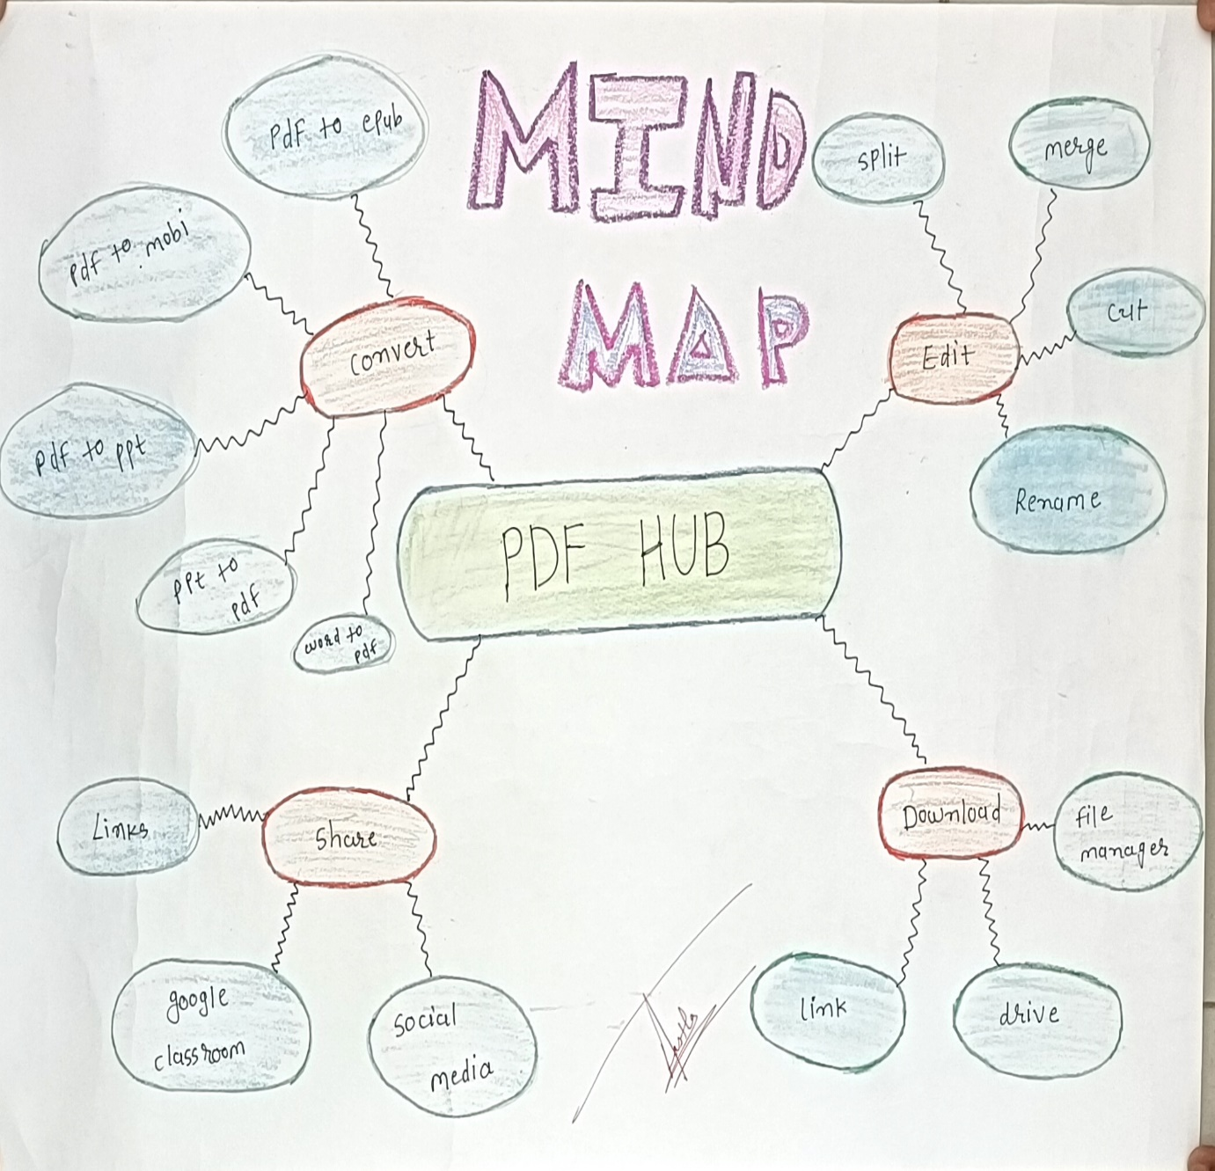

Mind Map

* **Learning Needs Matrix Canvas**

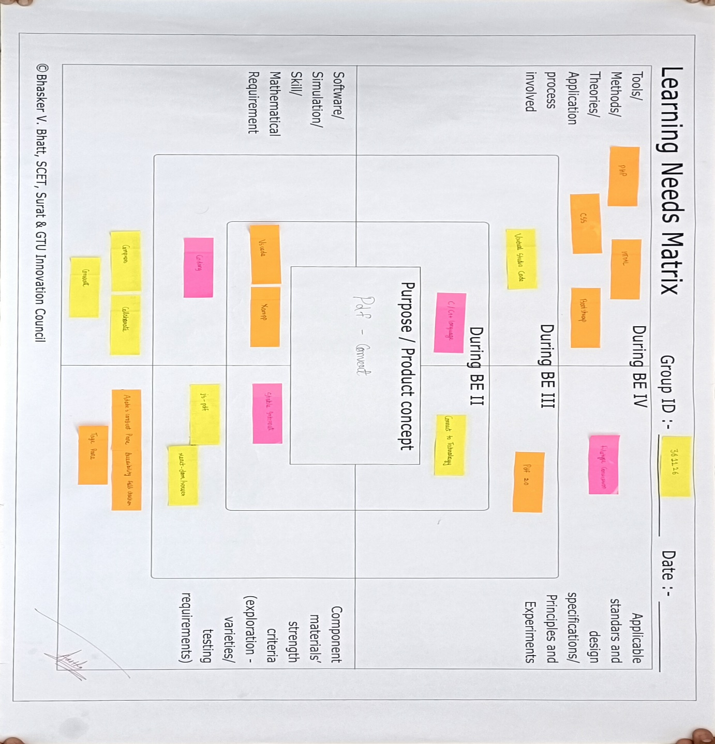

Learning Needs Matrix

* **Prototype**

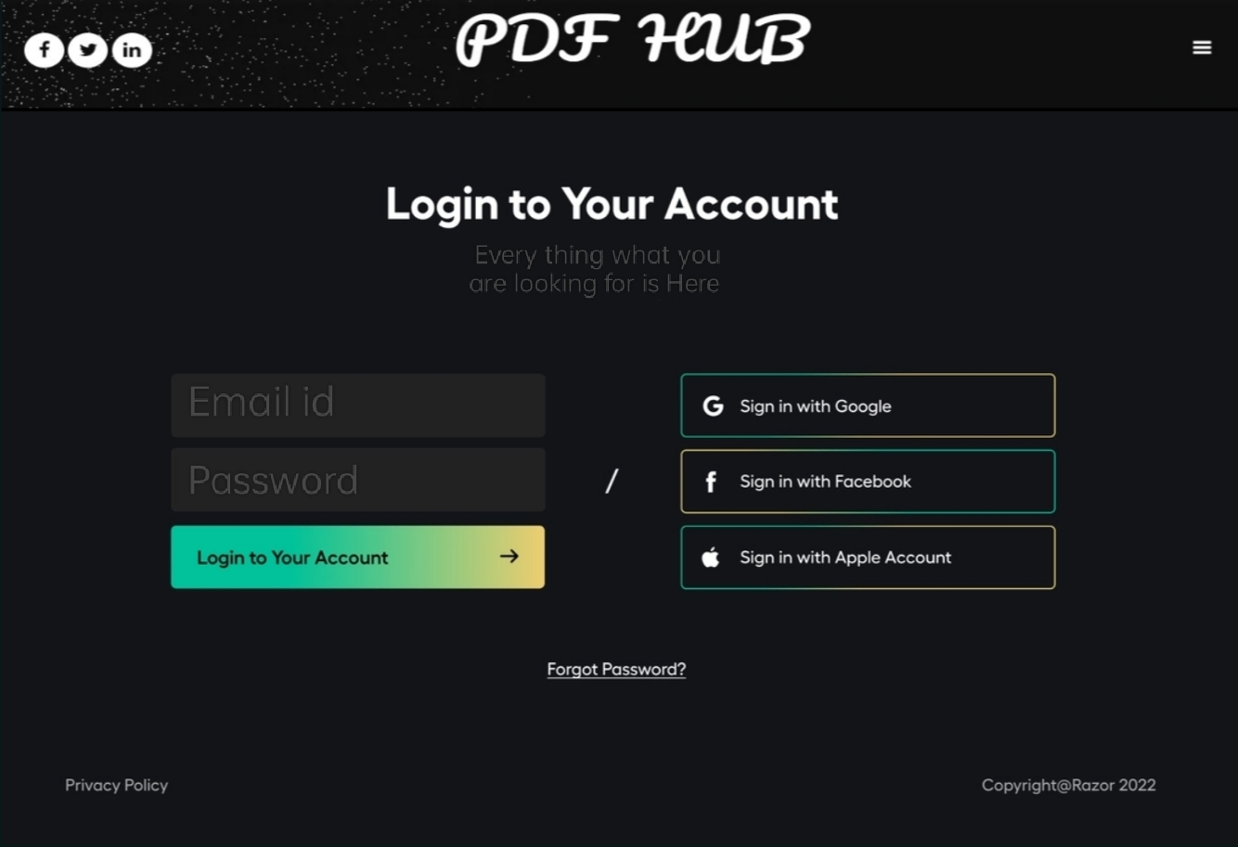

Login Page

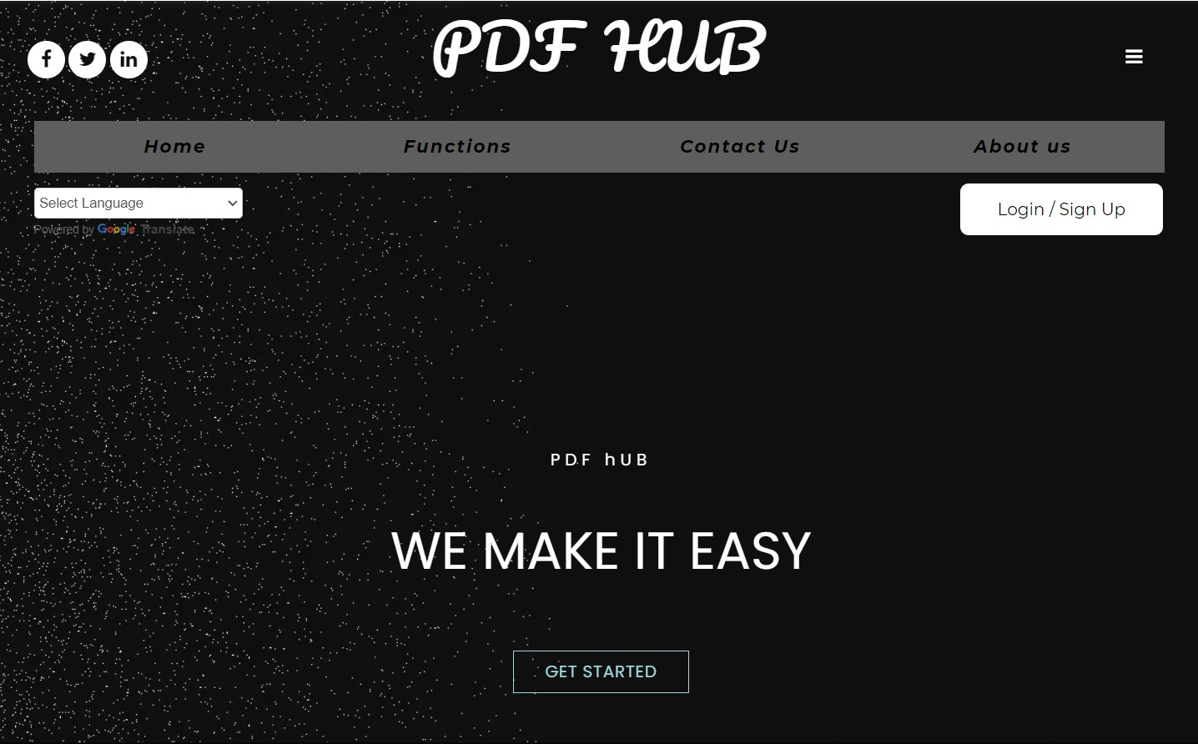

Home Page

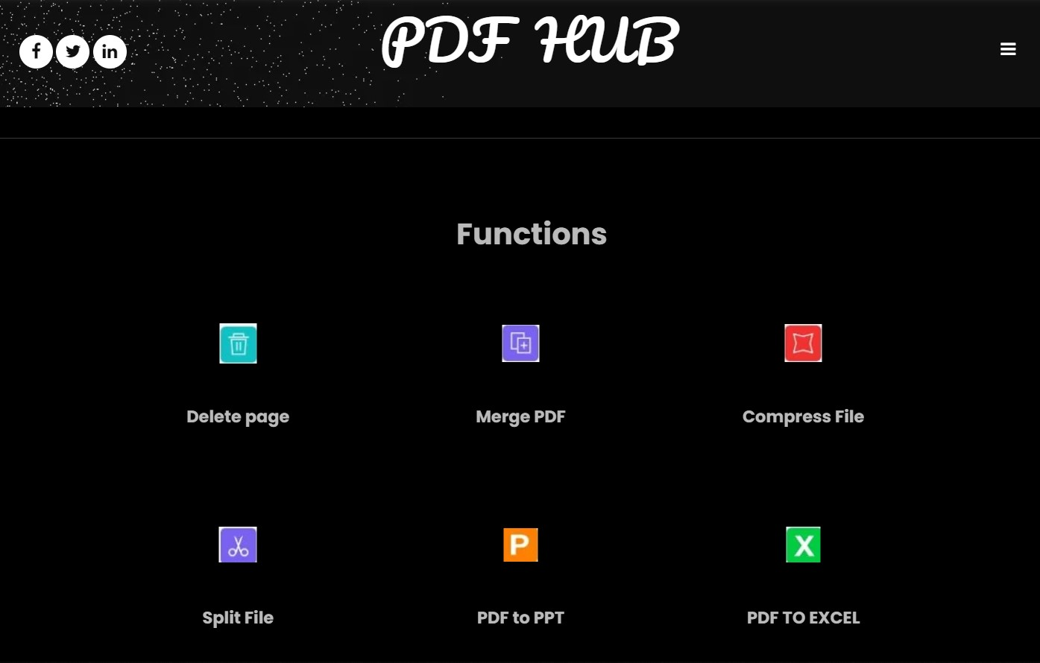

Functions

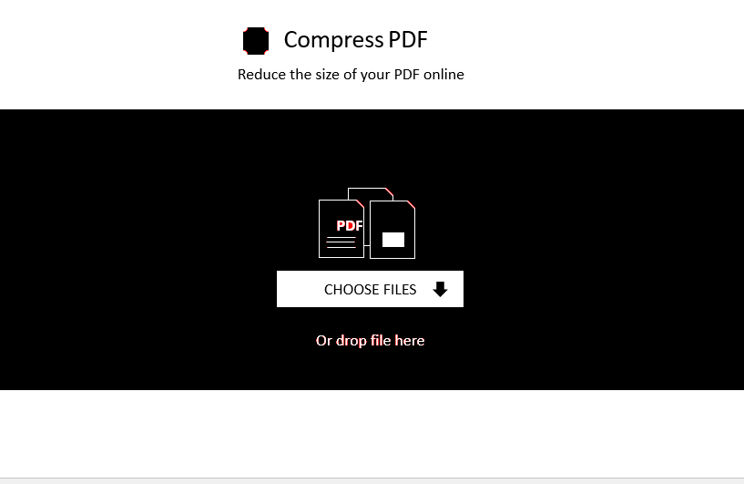

Compress Function

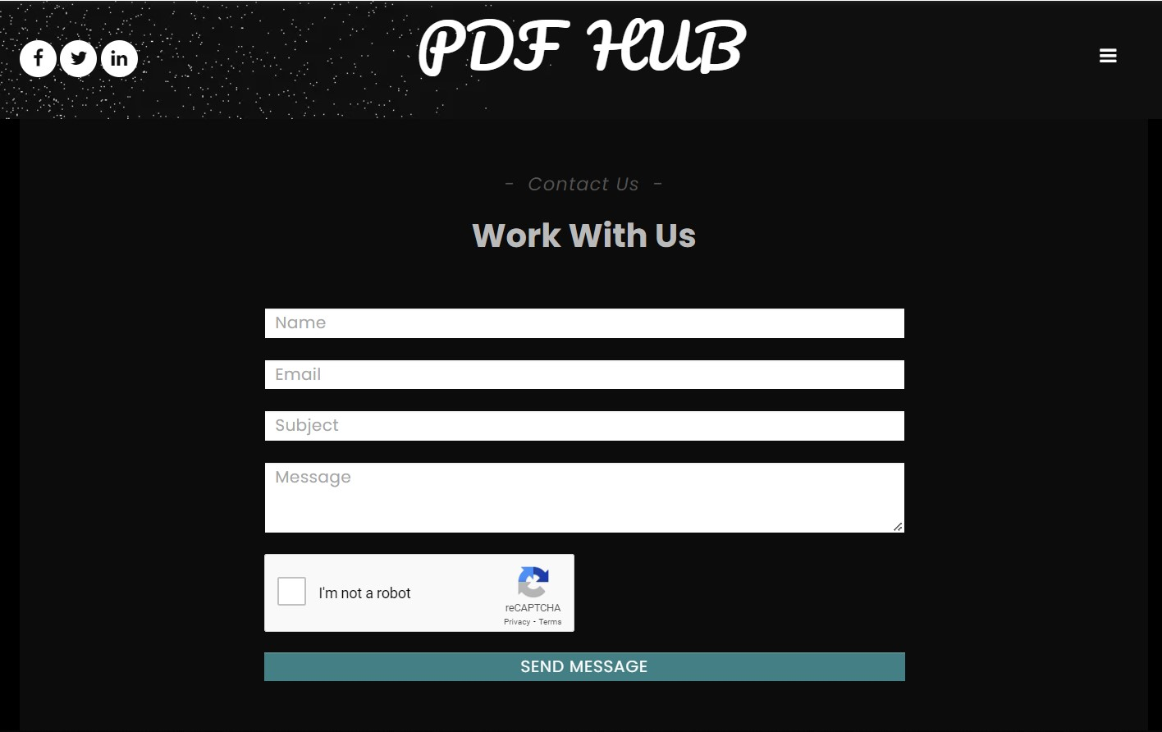

Contact Us